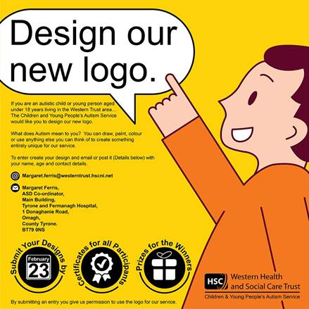
The Western Trust Children and Young People’s Autism Service want a new logo to represent their service and we need your help!

We are inviting autistic children and young people aged under 18 years living in the Western Trust area to design our new logo.
The theme is “What does Autism mean to you?”
Can we ask you to bring this competition to the attention of autistic children/young people and their families within your school.

Please print off the poster and display it within your school.

Certificates for all participants. Prizes for the winners

Closing date for entries is Friday 23rd February 2024

Kind Regards
Margaret

Margaret Ferris
ASD Co-ordinator/Service Improvement
Main Building
Tyrone & Fermanagh Hospital
1 Donaghanie Road
Omagh
Co.Tyrone
BT79 0NS

Telephone Number: 028 8283 5259/Internal Ext 234322
Email: Margaret.ferris@westerntrust.hscni.net

