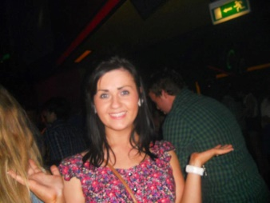
_{Gemma’s} Cycle & 5k
5k – Friday 26th April Cycle - Sunday 5th May 2022

er

8A Crilly’s Hill Road
CASTLEDERG
Co Tyrone Telephone No: 07817468451
BT81 7EW email:smchale59@hotmail.co.uk

Dear Sir/Madam

Gemma’s 5k and Cycle will continue in 2024.

Many people benefit from this funding as Gemma continues to ‘light up the lives of others’ through the fundraising efforts of The Gemma Mc Hale Foundation in keeping Gemma’s memory alive.

This year Gemma’s 5K will take place a week earlier than usual on Friday 26th April leaving Aghyaran Centre at 7.30pm. Mr Whippy will be there with free ice cream for the kids and party bags will be distributed to all children.

Gemma’s cycle will take place on Sunday 5th May leaving Aghyaran Centre at 10 am.

Gemma’s Foundation will continue to fund the provision of a Mindfulness/Relax Kids programme and Professional Counselling Services in our local Primary Schools.
Evaluation results reflect the positivity that such programmes bring to our kids.

We will also support MS, Castlederg and Cancer care within our community and a relatively new project we have undertaken is ‘A Bereavement Support Group’.

Our target each year is £10,000 and we would very much appreciate any sponsorship/donation you may wish to give towards Gemma’s 5K.

We are extremely grateful for your sponsorship/donations over the years and wish to thank you most sincerely for your continued support.

Cheques should be made payable to The Gemma Mc Hale Foundation or you may make a donation through Foundation PayPal account which is:

gemmasfoundation@gmail.com

Yours sincerely
Kieran & Siobhan Mc Hale
On behalf of The Gemma Mc Hale Foundation
(Registered N.I. Charity – Charity No: 106489)

